Basecamp Dossier 2024

Telmo Alexandre Pereira Claro
1072167
Teacher 1: Klein Hegeman, P. (Pascale)
Teacher 2: Vaziri, F. (Farzad)
Date:

Preface
This dossier has been developted for the purpose of collecting, structering and sharing my experience and growth in the BaseCamp. During these five months, I have learned the basics of programming using Python and developed on professional thought and skills.
Along the way I’ve made new friends, have developed as a professional and now I am sure that programming is want to do career-wise.
I want to use this introduction to thank my teachers for having the patience to understand and teach us, and want to thank my learning team and my classmates for all the support and all the good moments we had during this BaseCamp.
I will miss the thursday after school beer with everyone, the python related baking cake examples from Dr. Vaziri and the endless conversations about professional skills with miss Pascale!
Telmo Alexandre Pereira Claro
29-05-2024
Table of Contents
Feedback loop 4
Self-evaluation: Week 3 4
Feedback session: Report: week 4/5 6
Plan of approach: Learning goals: Week 6 7
Peer-evaluation: Week 7 8
Self-evaluation: Week 8 9
Feedback session: Report: Week 9/10 10
Plan of approach: Learning goals: Week 11 11
Peer-evaluation: Week 12 12
Self-evaluation: End conclusion: Week 13/14 15
CodeGrade 16
Assignments & problems 16
Class learning activities 21
Arch 1 21
Arch 2 21
Arch 3 21
Appendices 22
Table: Plan of approach. 22
Learning goal Professional Skills – First round 22
Completed peer evaluations learning team. 25
Other necessary attachments, which contribute to evidence of learning outcomes. 30

Feedback loop

Self-evaluation: Week 3
How do you feel about your choice of study program after the first few weeks?
After the first few weeks, I am confident about my study choice. I understand that things will become more difficult and complex, but for now, I am happy with it.
How do you experience Basecamp compared to your expectations beforehand?
I usually have low expectations for about everything, so I do not get disappointed. Basecamp has surprised me positively. I have enough time to work on my assignments, and the pace is balanced.
How do you feel about the class?
I do not have a strong opinion about the class. Everyone is doing their own thing as I am, and there has not been enough time for me to judge it.
How do you feel about your learning team?
I spend more time with my learning team than my class. We work well together, and I like my teammates.
What went well the past few weeks?
For the past few weeks, I have been working in advance, so everything is going well for now.
What did not go so well the past few weeks? Or what was difficult?
Sometimes I struggled with some problems because they required more knowledge than provided by the course material. Otherwise, everything went well.
What is your step-by-step plan if you get stuck?
First, I identify the problem. Second, I google it. Third, I try to grasp the logic and attempt to solve it myself. If I cannot, I will use a YouTube video or consult ChatGPT.
What resources do you have available to you for Basecamp?
I use the resources provided by Hogeschool Rotterdam, along with self-study and research.
What do you think about the content of Basecamp?
I am happy with the general content of Basecamp.
How do you feel about learning to program in Python?
I really love learning to program in Python! It is one of the most, if not the most, used programming languages, and I am looking forward to creating fun and interesting programs!
You have completed the study habits and skills checklist.
What was the result?
I scored 143 points.
“113-166 points: You have worked to develop a set of skills and habits that will facilitate academic success in higher education. Review the checklist to see where you need to sharpen your practices to get into the 'almost always' categories. Once you have identified the specific practices that need improvement, set yourself targeted study skills goals.”
To what extent do you recognize yourself in the results?
I agree with the results. I can improve myself and study more efficiently.

Feedback session: Report: week 4/5
What things are going well according to your teacher?
The teacher noted that I was doing well for these first weeks. She saw that I was sociable and that I fit well in the class. I communicate easily, and I enjoy working with my team.
Did you discuss things that could/should be improved? If so, what are they?
I told the teacher that I have a problem with studying and learning on my own. It can be overwhelming sometimes because previously in my school career, I have never studied for a test, for example, and I would like to learn that.
Part of that is planning. Previously, I never had the need to plan, but seeing how in the future I will have team projects and a lot more assignments, planning should become a norm for me.
Also, something that correlates to this is to keep the pace, not lose motivation after some more weeks or months, and maintain discipline.
Did you and your teacher make an agreement/agreements for the time coming?
Just to keep being myself, keep learning, do not stress, and enjoy!
How do you feel about the feedback received? Do you recognize the points that were discussed?
The feedback was good. I feel like I fit in this course, and I do recognize the points discussed and plan to work on them in the future.

Plan of approach: Learning goals: Week 6
My learning goal (learning) programming:
My learning goal with programming is to be up to date with the topics and the assignments.
My learning goal professional skills:
I do not have a learning goal for professional skills.

Peer-evaluation: Week 7
This is the feedback I received from my learning team:
Kacper: You are very diligent, and you put the work in to really understand the topics at hand. Only asking for help when you really get stuck.
Joshua: Telmo is a hard worker. He is usually working by himself, and even when he asks questions, he always wants to fully understand the concept before continuing.
Matt: You dedicate a lot of time and effort to really understand the material well, whether it is studying at home or at school. I appreciate how you are willing to ask questions when something is not clear.
Juan: Very helpful and great to work with, also always on track.
These are points for development:
Kacper: Try not to use ChatGPT.
Joshua: No comment.
Matt: You could be more present during our working days.
Juan: No comment.
This is what I do well:
Doing my own thing: My team likes how I work independently and only ask for help when I really need it. They appreciate that I am all about understanding stuff properly rather than just getting it done quickly.
Putting in the effort: Whether I am on-site with my learning team or working alone from home, I am always putting in the effort to get what we are learning. It is good to know my teammates value me asking questions when things are not clear.
These are points for development:
Be confident with my skills: It seems like I should trust my own brain a bit more and rely less on stuff like ChatGPT.
Being more engaged: I guess I could try to be more involved during our team activities and discussions. That means speaking up more or just being more present.

Self-evaluation: Week 8
How do you feel about your choice of study program now?
My choice of program was correct, and I feel good about this study.
How do you experience Basecamp compared to your expectations?
My expectations were met. I knew that it would get exponentially more difficult, and it is. More work and time are required.
What went well in recent weeks? Or what are you proud of?
I am proud that I set myself to work and practice new concepts and I am keeping up with the schedule.
What has not gone so well in recent weeks? Or what was difficult?
Last week I started getting behind mostly because I was stuck on one problem for too long. I did end up getting a grade 7 on CodeGrade for it, but it is still incomplete. The assignment for that week is done, and from previous weeks also.
To what extent does the schedule of Basecamp match your study pace?
At the start, I could do everything in the first couple of days. Now I use all days of the week plus the weekend to keep up with Basecamp. The jump in pacing was fast, but if it keeps like this, I should be fine.
Evaluation learning objectives
What learning objectives have you set?
Professional Skills: Deliver everything and keep up with the dossier.
Computer Programming: Not staying behind, grasp all the concepts.
What activities did you undertake to work on the learning objectives?
I just sat and worked on it.
What could you do in addition to what you have done so far? Or what could you do differently?
Nothing, I feel like my study method is good, and I am having relative success with it.

Feedback session: Report: Week 9/10

What things are going well according to your teacher
According to the teacher, I am on track, and it has been observed that I fit in with my learning team and that I am social. Basically, a continuation of the previous feedback session.
Did you discuss things that could/should be improved? If so, what are they?
During this feedback session, the teacher and I spent most of the time discussing what could be improved. It seems like sometimes our learning team can be a bit extroverted and loud. The objective of a learning team is to help each other and create a bond between students, but we should respect other people.
It was also discussed that I tend not to put in the effort for the professional skills assignments in the sense that I could think more about certain aspects like what my goal is. We had an extensive conversation about it, and it was helpful.
Did you and your teacher make an agreement for the time coming?
Not really an agreement, but it made me reflect on how I approach the professional skills.
How do you feel about the feedback received? Do you recognise the points that were discussed?
I fully agree and recognize what was spoken and I want to improve further. I also hope that my feedback to the teacher will be taken seriously and reflected in the coming weeks/Arches.

Plan of approach: Learning goals: Week 11
Learning Goal: Professional Skills
My goal for professional skills is to plan my weekly work and private life better. For this, I will use Google Calendar to maintain a schedule. Each weekend, I will make a plan for the next week until the end of BaseCamp. This will give me better insight into my week and the balance between private and work life. It will also force me to follow a schedule and not fall behind.
Learning Goal: Programming
My goal for programming skills is to learn the right names of Python and know their definitions. I will achieve this by creating my own cheat sheet where I can write down the names and provide examples. I will do this until the end of BaseCamp. This will provide me with the correct concepts and names for Python-related topics.

Peer-evaluation: Week 12
Part A - Peer Evaluation
How or with what knowledge/skill can you help/support other team members?
With what could you use help/support from other team members?
Describe for each team member at least one thing he/she does well and at least. This is what you do well:
Team member 1 Matt: Matt is focused and wants to learn and finish BaseCamp. Since last time, he has been more active in telling us what he has been doing. I know he is up to date and he was busy reading the book and writing his own cheat sheet.
Team member 2 Joshua: Joshua is becoming really good at programming and developing a programmer-like mind. He also helps us the most, he is always available to help and does it freely!
Team member 3 Julian: This last arch, Julian was more social and helped with professional skills. He also helped me and Matt with coding, and he is great to work with.
Team member 4 Kacper: Kacper, like Joshua, is becoming really good at programming. In four days, he finished the whole Arch 3 and was working together with Joshua on extra assignments from Farzad!
This is what I see as a point for development:
Team member 1 Matt: Don’t be afraid to just write code and try it out! This helps create logic and this way you will learn how to make the assignments easier. I say this because I see you always want a 10 in everything, but I feel like at the moment it’s not possible.
Team member 2 Joshua: I don’t have points of improvement for Joshua.
Team member 3 Julian: Try to communicate more with us, tell us what you have been doing, and don’t be afraid to ask for help!
Team member 4 Kacper: The only thing I think Kacper has to be more attentive to is the way he offers help. Try to help more and develop the skill of helping and explaining!
This is the feedback I received from my learning team:
This is what I do well:
Kacper: I have noticed that you use less ChatGPT and prefer to struggle a bit on your own to understand the topics at hand.
Joshua: Same as last peer-review, you work well and ask questions when you are stuck on assignments. In class presentations, you are always active and answer the teachers' questions.
Matt: You are a very positive person, and your attitude helps our teamwork. I have noticed that you are doing more tasks on your own instead of searching for them online.
Juan: You always aim for the 10 on your assignments, keep doing that!
These are points for development:
Kacper: Try to actually be present on the online days; this will make you be ahead of schedule.
Joshua: When you are programming, be less quick to search something on the internet or a LLM. Sometimes you know the answer yourself, but you were too quick to search it up.
Matt: You aim for a 10/10 on CodeGrade, but you could accept the score you have and work on other assignments. This way, you might get ahead of the schedule.
Juan: Maybe use OpenAI a little less for your code, but try and learn from it (if you are not doing already).
Part B - Code Review
Which programming assignment did of which student did you review?
Programming assignment: A10W10A1
Student: Telmo Pereira Claro
Do the variables have correct names? (Is it a description of what it contains? Which one(s) would you name differently? Are there obsolete variables? How does this code compare to your code?)
The variables have correct names depending on the value that they hold. All of the variables are used, no obsolete ones. I tend to name my variables slightly differently but still in the same region. The variables are understandable. Some of them could be named a bit shorter, as the context already tells what the variables are.

Does the code do what it is supposed to do? And is the code clear in what it does? How does this compare to how you solved it?
The code is functional; it does what it needs to do. It is readable and clear in what it does. Some of the lines could be shortened like:
current_time = datetime.now()
current_time = current_time.replace(microsecond=0)
Could be just:
current_time = datetime.now().replace(microsecond=0)
The logic behind solving the problem was similar between mine and Telmo’s code.
How do the if/while statements look? (Think about: are they clear and clean, are there obsolete statements?) How does this compare to how you solved it?
The if and while statements look clean; there is no unnecessary mess with them. All are short and do exactly what they are meant to do. The if statements check for similar things in mine and Telmo’s code.
Are the PEP8 guidelines for Python applied? Where does this go well? Where can it be improved?
PEP8 has been implemented cleanly besides line 89, which is a tad bit too long.
Is there a simpler solution possible? Compare your code with that of your fellow student. What differences and similarities do you see?
There might be a simpler solution possible; compared to my code, it is just a bit longer. The code logic is pretty similar.
How is a wrong input handled? (If applicable to the assignment you chose)
There is no wrong input.
Write a short summary of your findings in Part B questions 3 to 8. What goes well? What can be improved? What differences and similarities do you notice when you compare your code with the code of your fellow student?
The code is clear to read and understandable. The variables are named correctly; some of them could just be named a bit shorter. The code in general works well and in a very similar way like mine. The code could be written a bit shorter in some lines. Further, PEP8 is applied correctly, and the solution is simple enough.

Self-evaluation: End conclusion: Week 13/14

CodeGrade

Assignments & problems

Assignment description | CodeGrade-link
A1W1A1 - Year to month & day | https://app.codegra.de/courses/6294/assignments/53619/submissions
A1W1A2 - Tax & Tip | https://app.codegra.de/courses/6294/assignments/53620/submissions
A1W1P1 - Hello name | https://app.codegra.de/courses/6294/assignments/53627/submissions
A1W1P2 - Year to month and day | https://app.codegra.de/courses/6294/assignments/53628/submissions
A1W1P3 - Room area | https://app.codegra.de/courses/6294/assignments/53629/submissions
A1W1P4 - Weight calculation | https://app.codegra.de/courses/6294/assignments/53630/submissions
A1W1P5 - Four-digit sum | https://app.codegra.de/courses/6294/assignments/53631/submissions
A1W1P6 - Hours, minutes, and seconds | https://app.codegra.de/courses/6294/assignments/53632/submissions
A1W2A1 - Immediate successor | https://app.codegra.de/courses/6294/assignments/53621/submissions
A1W2P1 - Even or Odd | https://app.codegra.de/courses/6294/assignments/53633/submissions
A1W2P2 - Leap year | https://app.codegra.de/courses/6294/assignments/53634/submissions
A1W2P3 - Sides to shape | https://app.codegra.de/courses/6294/assignments/53635/submissions
A1W2P4 - Triangle type | https://app.codegra.de/courses/6294/assignments/53636/submissions
A1W2P5 - Dutch holidays | https://app.codegra.de/courses/6294/assignments/53637/submissions
A1W2P6 - Dog years | https://app.codegra.de/courses/6294/assignments/53638/submissions
A1W2P7 - Chessboard colors | https://app.codegra.de/courses/6294/assignments/53639/submissions
A1W2P8 - License plate | https://app.codegra.de/courses/6294/assignments/53640/submissions
A1W3A1 - Predefined templates | https://app.codegra.de/courses/6294/assignments/53622/submissions
A1W3P1 - Simple palindrome | https://app.codegra.de/courses/6294/assignments/53641/submissions
A1W3P2 - Advanced palindrome | https://app.codegra.de/courses/6294/assignments/53642/submissions
A1W3P3 - Modular rectangles | https://app.codegra.de/courses/6294/assignments/53643/submissions
A1W3P4 - Celsius to Fahrenheit | https://app.codegra.de/courses/6294/assignments/53644/submissions
A1W3P5 - Multiplication table | https://app.codegra.de/courses/6294/assignments/53645/submissions
A1W3P6 - Binary to Decimal | https://app.codegra.de/courses/6294/assignments/53646/submissions
A1W3P7 - Truth tables | https://app.codegra.de/courses/6294/assignments/53648/submissions
A1W4L1 - Learning Activity | https://app.codegra.de/courses/6294/assignments/53690/submissions
A1W4L2 - Learning Activity | https://app.codegra.de/courses/6294/assignments/53691/submissions
A1W4L3 - Learning Activity | https://app.codegra.de/courses/6294/assignments/53692/submissions
A2W5A1 - Processing student data | https://app.codegra.de/courses/6294/assignments/53623/submissions
A2W5P1 - Automated arithmetic | https://app.codegra.de/courses/6294/assignments/53650/submissions
A2W5P2 - Taxi Fares | https://app.codegra.de/courses/6294/assignments/53649/submissions
A2W5P3 - Triangle Checker | https://app.codegra.de/courses/6294/assignments/53651/submissions
A2W5P4 - Integer checker | https://app.codegra.de/courses/6294/assignments/53653/submissions
A2W5P5 - Simple Password Generator | https://app.codegra.de/courses/6294/assignments/53652/submissions
A2W5P6 - Twelve Days of Christmas | https://app.codegra.de/courses/6294/assignments/53654/submissions
A2W6A1 - Address book | https://app.codegra.de/courses/6294/assignments/53624/submissions
A2W6P1 - Unique Characters | https://app.codegra.de/courses/6294/assignments/53656/submissions
A2W6P2 - Book Information | https://app.codegra.de/courses/6294/assignments/53657/submissions
A2W6P3 - Valid Password Checker | https://app.codegra.de/courses/6294/assignments/53658/submissions
A2W6P4 - Average Temperatures | https://app.codegra.de/courses/6294/assignments/53659/submissions
A2W6P5 - Morse Code Translator | https://app.codegra.de/courses/6294/assignments/53660/submissions
A2W7A1 - Name hasher | https://app.codegra.de/courses/6294/assignments/53625/submissions  (This assignment was made together with Juan, therefore we have 100% the same code, we worked together because we were behind on schedule)
A2W7P1 - Daily Temperatures Amsterdam | https://app.codegra.de/courses/6294/assignments/53655/submissions
A2W7P2 - Netflix titles | https://app.codegra.de/courses/6294/assignments/53662/submissions
A3W09A1 - Car parking | https://app.codegra.de/courses/6294/assignments/53626/submissions
A3W09P1 - Car dealer program | https://app.codegra.de/courses/6294/assignments/53663/submissions
A3W09P2 - Product shop | https://app.codegra.de/courses/6294/assignments/53664/submissions
A3W09P3 - Password manager | https://app.codegra.de/courses/6294/assignments/53665/submissions
A3W09P4 - Distance Converter | https://app.codegra.de/courses/6294/assignments/53666/submissions
A3W10A1 - Car parking logger | https://app.codegra.de/courses/6294/assignments/53647/submissions
A3W10O1 - File line numbers | https://app.codegra.de/courses/6294/assignments/53669/submissions
A3W10O2 - Word to password generator | https://app.codegra.de/courses/6294/assignments/53672/submissions
A3W10O3 - Repeating word detector | https://app.codegra.de/courses/6294/assignments/53673/submissions
A3W10O4 - Sensitive word replacer | https://app.codegra.de/courses/6294/assignments/53674/submissions
A3W10P1 - Python head program | https://app.codegra.de/courses/6294/assignments/53667/submissions
A3W10P2 - Python tail program | https://app.codegra.de/courses/6294/assignments/53668/submissions
A3W10P3 - Longest word identifier | https://app.codegra.de/courses/6294/assignments/53670/submissions
A3W10P4 - Word occurrences | https://app.codegra.de/courses/6294/assignments/53671/submissions
A3W10P5 - Comments remover | https://app.codegra.de/courses/6294/assignments/53678/submissions
A3W10P6 - Comments checker | https://app.codegra.de/courses/6294/assignments/53675/submissions
A3W11A1 - Car parking extended | https://app.codegra.de/courses/6294/assignments/53661/submissions
A3W11P1 - Movie collection | https://app.codegra.de/courses/6294/assignments/53676/submissions
A3W11P2 - Banned video games | https://app.codegra.de/courses/6294/assignments/53677/submissions
A4W13A1 - Car parking final | https://app.codegra.de/courses/6294/assignments/53681/submissions
A4W13P1 - Student database | https://app.codegra.de/courses/6294/assignments/53679/submissions
A4W13P2 - Bookstore | https://app.codegra.de/courses/6294/assignments/53680/submissions
A4W14A1 - Name hasher 2.0 | https://app.codegra.de/courses/6294/assignments/53684/submissions
A4W14P1 - Sorting strings | https://app.codegra.de/courses/6294/assignments/53682/submissions
A4W14P2 - Code performance | https://app.codegra.de/courses/6294/assignments/53683/submissions
A4W15A1 - Folder structure
A4W15P1 - Positive numbers recursion
A4W15P2 - Factorial
A4W15P3 - Find in list
A4W16M1 - Final Project  (master assignment) | https://app.codegra.de/courses/2941/assignments/25642/submissions?mine=false&search=1072167

Class learning activities

Arch 1

 | CodeGrade-link
A1W4L1 - Learning Activity | https://app.codegra.de/courses/6294/assignments/53690/submissions
A1W4L2 - Learning Activity | https://app.codegra.de/courses/6294/assignments/53691/submissions
A1W4L3 - Learning Activity | https://app.codegra.de/courses/6294/assignments/53692/submissions

Arch 2

Assignment description | CodeGrade-link
A1W8L1 - Learning Activity | https://app.codegra.de/courses/6294/assignments/53693/submissions
A1W8L2 - Learning Activity | https://app.codegra.de/courses/6294/assignments/53694/submissions
A1W8L3 - Learning Activity | https://app.codegra.de/courses/6294/assignments/53695/submissions

Arch 3

Assignment description | CodeGrade-link
A1W12L1 - Learning Activity | https://app.codegra.de/courses/6294/assignments/53696/submissions
A1W4122 - Learning Activity | https://app.codegra.de/courses/6294/assignments/53697/submissions
A1W4123 - Learning Activity | https://app.codegra.de/courses/6294/assignments/53698/submissions

Appendices

Table: Plan of approach.

Learning goal Professional Skills – First round
The first learning goal is about professional skills; student success, research and problem solving (see also study guide). To formulate your learning objective, use the SMART method (see PPT and explanation in class). For this we have a step-by-step plan. To do this, complete the following questions:

Specific | What is the problem or situation? What do you want to develop when it comes to professional skills?  I don’t have a problem.
Measurable | When will you know you have realised your goal? How can others see this? E.g. How often am I going to do it? How many hours will I spend on it?  N/A
Acceptable | Do you stand behind your learning goal and do you have sufficient motivation for it? Is the goal achievable? What qualities and skills can you use to achieve the learning goal??  N/A
Realistic | Is my learning goal realistic? Do I have the knowledge, resources to achieve my learning goal? How can others possibly help you achieve your learning goal? Who is/are they? Is the learning goal not too simple?  N/A
Time | Within what time do you want to achieve your learning goal? At what times will I work on my learning goal?  N/A
My learning goal professional skills:
I don’t have a learning goal for professional skills.

- Learning goal programming
Specific | What is the problem or situation? What do you want to develop when it comes to programming skills?  I understand the basics of each topic but I want to practice more, go more in depth.
Measurable | When will you know you have realised your goal? How can others see this? E.g. How often am I going to do it? How many hours will I spend on it?  It’s a working in progress, with programming I always find something I don’t know, so everytime I work on it I learn something, step by step, stone by stone the castle is built!
Acceptable | Do you stand behind your learning goal and do you have sufficient motivation for it? Is the goal achievable? What qualities and skills can you use to achieve the learning goal??  Yes, motivated and ready!
Realistic | Is my learning goal realistic? Do I have the knowledge, resources to achieve my learning goal? How can others possibly help you achieve your learning goal? Who is/are they? Is the learning goal not too simple?  Yes, it is realistic.
Time | Within what time do you want to achieve your learning goal? At what times will I work on my learning goal?  Learning is an infinite process :D

My learning goal (learning) programming:
My learning goal with programming is to be up to date with the topics and the assignments.
Learning goal Professional Skills – Second round
Specific | What is the problem or situation? What do you want to develop when it comes to professional or programming skills?  For professional skills:  A professional problem I have right now is that the way I have been planning my weeks are not as efficient as they should, I want to keep a balance between private life and my study. Also inside BaseCamp I want to have a more open mind to develop myself professionally and not only focus on programming skills.  For programming skills:  Every new week, when I get a new learning material I usually understand the concepts and I can put it in practice but I don’t remember the names of things like what an object is, or what is a byte exactly. So my goal is to learn more “theory”.
Measurable | When will you know you have realised your goal? How can others see this? E.g. How often am I going to do it? How many hours will I spend on it?  For professional skills:  I will know I have realised my goal when at the end of the week I feel satisfied with my weekly life balance, further I will know I’ve realised my second “goal” when at the end of BaseCamp I have developed a professional mind set.  For programming skills:  When we do the next formative test, I want to be able to understand the questions more easily or when I try to explain my code I want to be able to talk about it in more technical terms.  For both of this skills, I can be sure I have achieved my goals when I get positive feedback from the teachers or my learning team.
Acceptable | Do you stand behind your learning goal and do you have sufficient motivation for it? Is the goal achievable? What qualities and skills can you use to achieve the learning goal?  For professional skills:  Spend more time on the professional skills assignments and reflecting about myself.  For programming skills:  Write down and study more pyhton or programming theory.
Realistic | Is my learning goal realistic? Do I have the knowledge, resources to achieve my learning goal? How can others possibly help you achieve your learning goal? Who is/are they? Is the learning goal not too simple?  For professional skills:  My goals is realistic and I have everything I need to realise it, just have to do it.  For programming skills:  Same as professional skills.
Time | Within what time do you want to achieve your learning goal? At what times will I work on my learning goal?  For professional skills:  At the end of next Arch, I want to see improvement from here.  For programming skills:  At the next formative test or at the end of Basecamp.

Completed peer evaluations learning team.
First Round - Part A Peer Evaluation
- Give some of the do’s and don’ts of giving and receiving feedback.
Do’s:
  - Be specific
  - Be constructive
  - Be honest
  - Provide examples
Don’ts:
  - No personal attacks
  - No general criticism
  - Not only negative comments
- Describe for each team member at least one thing he/she does well and at least one point for development.
This is what you do well:
  - Team member 1 — Joshua: He is already done with everything before the arch even begins; keep going, you got this easy.
  - Team member 2 — Matt: He is learning at his own pace but on schedule, so until now, I think he is doing that well.
  - Team member 3 — Juan: Juan always looks for different ways to approach the exercises/problems/assignments, and he is always available to help and, when needed, also asks for help, no stress.
  - Team member 4 — Kacper: Kacper is doing well and ahead of schedule!
This is what I see as a point for development:
  - Team member 1 — Joshua: No feedback.
  - Team member 2 — Matt: Feedback is to maybe update us more on where he is with the exercises/problems/assignments. I usually know what everyone is doing but not Matt.
  - Team member 3 — Juan: I don't have feedback for Juan; I think we are both on the same page compared to our teammates.
  - Team member 4 — Kacper: No feedback for Kacper, keep on keeping on!
- Discuss the feedback you wrote down in question 2 with your team members. Write down what feedback you received from your team members.
This is the feedback I received from my learning team (write down multiple items):
  - Kacper: You are very diligent and you put the work in to really understand the topics at hand. Only asking for help when you really get stuck.
  - Joshua: Telmo is a hard worker; he is usually working by himself and even when he asks questions, he always wants to fully understand the concept before continuing.
  - Matt: You dedicate a lot of time and effort to really understand the material well, whether it's studying at home or at school. I appreciate how you're willing to ask questions when something isn't clear.
  - Juan: Very helpful and great to work with, also always on track.
These are points for development:
  - Kacper: Try not to use ChatGPT.
  - Joshua: No comment.
  - Matt: You could be more present during our working days.
  - Juan: No comment.
This is what I do well:
  - Doing My Own Thing: My team likes how I work independently and only ask for help when I really need it. They appreciate that I'm all about understanding stuff properly rather than just getting it done quickly.
  - Putting in Effort: Whether I'm hitting the books at home or getting stuck into discussions at school, I'm always putting in the effort to get what we're learning. It's good to know my teammates value me asking questions when things aren't clear.
These are points for development:
  - Less ChatGPT, More Me: It seems like I should trust my own brain a bit more and rely less on stuff like ChatGPT.
  - Being More Engaged: I guess I could try to be more involved during our team activities and discussions. Maybe that means speaking up more or just being more present.
Part B Code Review
1. Which programming assignment of which student did you review?
- Programming assignment: Valid Password Week 06
- Student: Ryan
2. Do the variables have correct names?
- The variables do have the correct name, and there are no obsolete variables. Both codes have the same principle. Ryan separated each function and sets, while I dumped everything in a big loop!
3. Does the code do what it’s supposed to do?
- The code is clear and does what it’s supposed to do. Mine is less clear but also functional.
4. How do the if/while statements look?
- The if/else statements are really clear and clean, with no obsolete statements.
5. Are the PEP8 guidelines for Python applied?
- All PEP8 guidelines for Python are applied.
6. Is there a simpler solution possible?
- There isn’t really a simpler solution, just different.
7. How is a wrong input handled?
- Wrong inputs are handled properly. If a user inputs a wrong input, the tries count goes down as it should.
8. Summary of Findings: Ryan's code for the Valid Password Week 06 assignment is well put together. He names his variables clearly and organizes his code neatly into separate functions, which makes it easy to follow. His code also adheres to the rules for writing Python neatly. It does what it's supposed to and handles wrong inputs properly. Comparing it to my own code, I noticed we took slightly different approaches, but both work fine. In the end, Ryan's solution is easy to understand, works well, and follows good coding practices.
Peer evaluation Week 12 – Round two
Part A Peer Evaluation
- How or with what knowledge/skill can you help/support other team members?
- I can support my team members with coding up to this week. My dossier up to this moment is very unorganized so not a great help.
- With what could you use help/support from other team members?
- I can’t really complain, my team members already help me and support me a lot!
Describe for each team member at least one thing he/she does well and at least.
This is what you do well:
- Matt: Matt is focused and wants to learn and finish BaseCamp. Since last time, he has been more active in telling us what he has been doing. I know he is up to date and he was busy reading the book and writing his own cheat sheet.
- Joshua: Joshua is becoming really good at programming and developing a programmer-like mind. He also helps us the most, he is always available to help and does it freely!
- Julian: This last arch, Julian was more social and helped with professional skills. He also helped me and Matt with coding, and he is great to work with.
- Kacper: Kacper, like Joshua, is becoming really good at programming. In four days, he finished the whole Arch 3 and was working together with Joshua on extra assignments from Farzad!
This is what I see as a point for development:
- Matt: Don’t be afraid to just write code and try it out! This helps create logic and this way you will learn how to make the assignments easier. I say this because I see you always want a 10 in everything but I feel like at the moment it’s not possible.
- Joshua: I don’t have points of improvement for Joshua.
- Julian: Try to communicate more with us, tell us what you have been doing, and don’t be afraid to ask for help!
- Kacper: The only thing I think Kacper has to be more attentive to is the way he offers help. Try to help more and develop the skill of helping and explaining!
- This is the feedback I received from my learning team:
This is what I do well:
- Kacper: I have noticed that you use less ChatGPT, and prefer to struggle a bit on your own to understand the topics at hand.
- Joshua: Same as last peer-review, you work well and ask questions when you are stuck on assignments. In class presentations, you are always active and answer the teachers' questions.
- Matt: You are a very positive person, and your attitude helps our teamwork. I have noticed that you are doing more tasks on your own instead of searching for them online.
- Juan: You always aim for the 10 on your assignments, keep doing that!
These are points for development:
- Kacper: Try to actually be present on the online days, this will make you be ahead of schedule.
- Joshua: When you are programming, be less quick to search something on the internet / a LLM. Sometimes you know the answer yourself, but you were too quick to search it up.
- Matt: You aim for a 10/10 on CodeGrade, but you could accept the score you have and work on other assignments. This way, you might get ahead of the schedule.
- Juan: Maybe use open AI a little less for your code but try and learn from it (if you are not doing already).
Part B Code Review
Which programming assignment of which student did you review?
- Programming assignment: A10W10A1
- Student: Telmo Pereria Claro
Do the variables have correct names?
- The variables have correct names depending on the value that they hold. All of the variables are used, no obsolete ones. I tend to name my variables slightly differently but still in the same region. The variables are understandable. Some of them could be named a bit shorter, as the context already tells what the variables are.
Does the code do what it is supposed to do? And is the code clear in what it does?
- The code is functional, it does what it needs to do. It is readable and clear in what it does. Some of the lines could be shortened like:
current_time = datetime.now()
current_time = current_time.replace(microsecond=0)
Could be just:
python
current_time = datetime.now().replace(microsecond=0)
The logic behind solving the problem was similar between mine and Telmo’s code.
How do the if/while statements look?
- The if and while statements look clean, there is no unnecessary mess with them. All are short and do exactly what they are meant to do. The if statements check for similar things in mine and Telmo’s code.
Are the PEP8 guidelines for Python applied?
- PEP8 has been implemented cleanly besides line 89, which is a tad bit too long.
Is there a simpler solution possible?
- There might be a simpler solution possible, compared to my code it is just a bit longer. The code logic is pretty similar.
How is a wrong input handled?
- There is no wrong input
Write a short summary of your findings in Part B question 3 to 8. What goes well? What can be improved? What differences and similarities do you notice when you compare your code with the code of your fellow student?
- The code is clear to read and understandable. The variables are named correctly, some of them could just be named a bit shorter. The code in general works well and in a very similar way like mine. The code could be written a bit shorter in some lines. Further PEP8 is applied correctly, and the solution is simple enough.

Other necessary attachments, which contribute to evidence of learning outcomes.
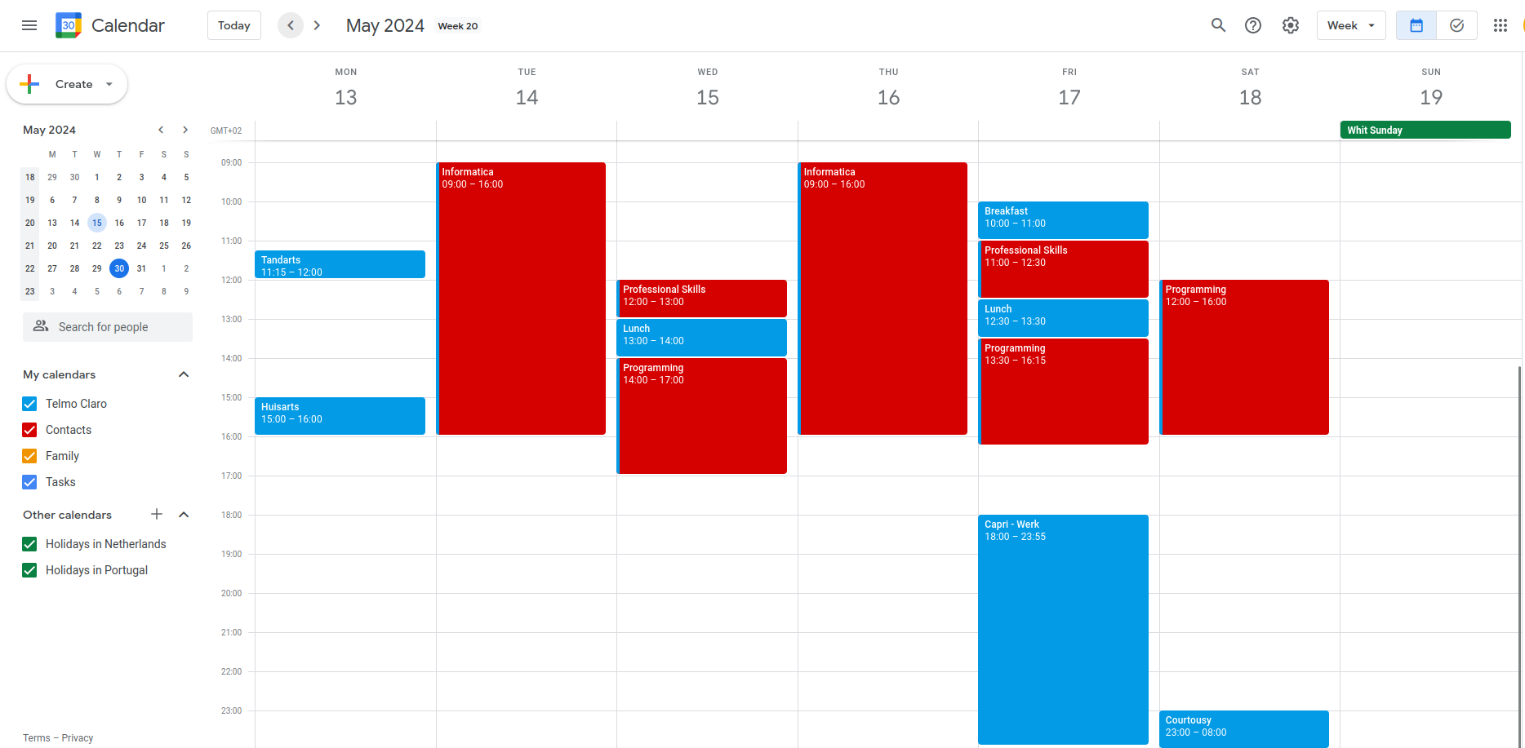
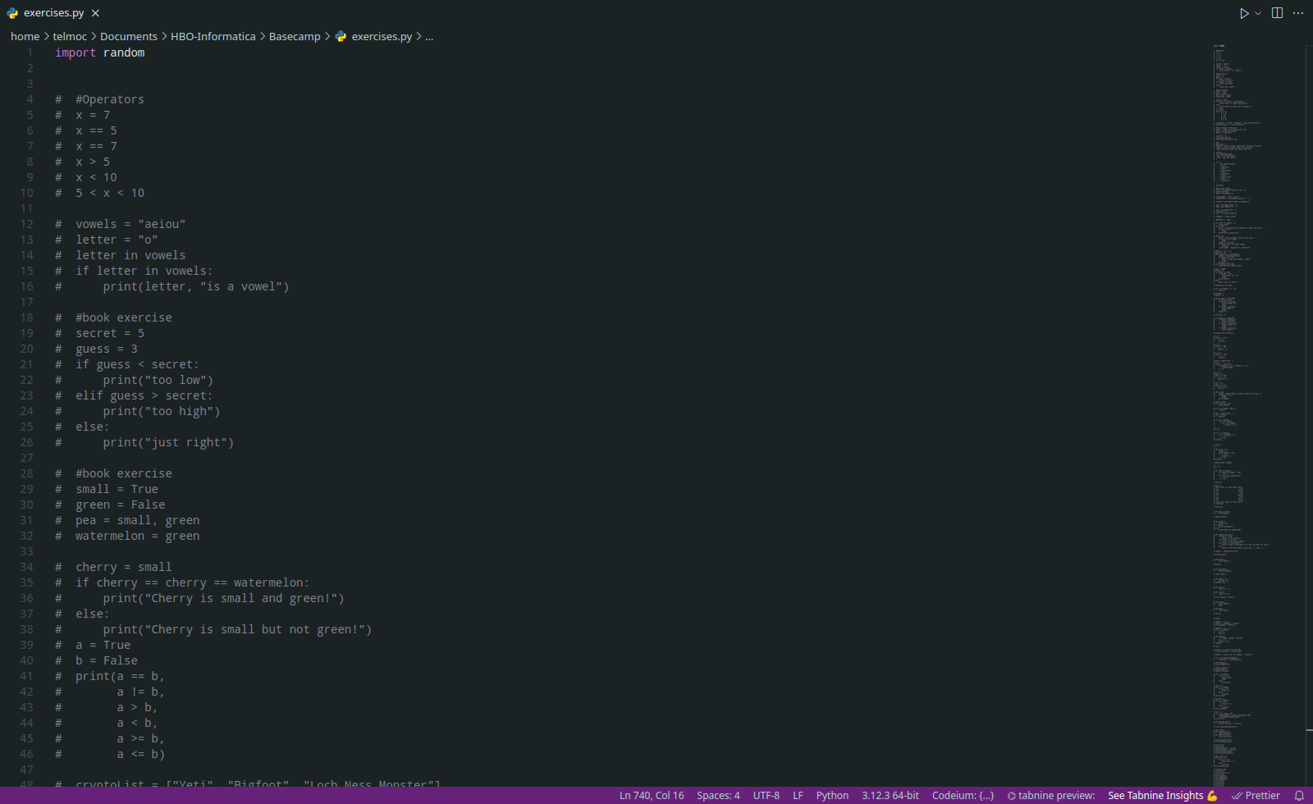
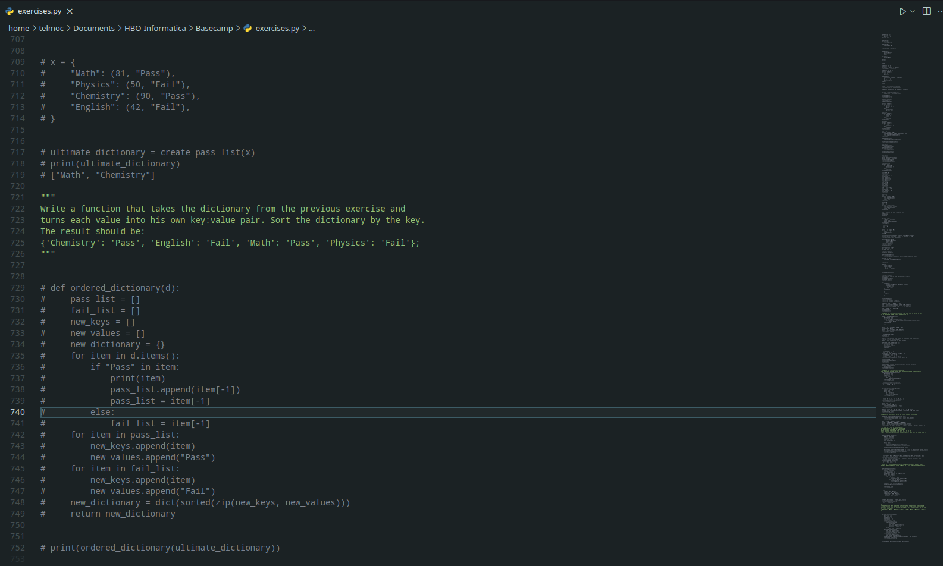
Evidence of weekly planning using Google Calendar
Evidence of practice python and understanding concepts

